Coach Notes: Webinar Series for 2022 PP2 Water Supply
This series of short webinars, written by Nicky Desoe, Deputy National Director of Future Problem Solving Program, is designed to help you coach your junior students through Water Supply.

Webinar 1 Working in teams
Research
Webinar 2 Future Scene
Problems and Challenges – Step 1
Webinar 3 Identifying an Underlying Problem – Step 2
Webinar 4 Solutions - Step 3
Webinar 5 Criteria – Step 4 and Step 5
Webinar 6 Action Plan – Step 6

Webinar 2 Coach Notes
Webinar 2 - Unpacking the Future Scene – Read and reread, highlight, charge
STEP 1 - brainstorming and writing PROBLEMS and CHALLENGES

Resources referred to in webinar
- FPS Category List
- GIPS Future Scene for Water Supply
- Flexibility Warm Up (slide 7)
- Category Worksheet (slide 13)

Student Pre-work
Read PP2 Future Scene – Water Supply

Key Points of Webinar
- Use the category list to broaden your thinking and encourage lateral thinking in identifying problems/challenges
- Consider what each category encapsulates. Delve into the Greek and Latin roots of these words
- Include warm up activities for using the category list
- What will these categories look like in the future e.g. Transportation?
Activity: Lateral Thinking – Flexibility Warm Up - Choose a colour (not green) and complete the table with ideas that you can connect to each category
Unpacking the future scene
- Highlight anything you think is a problem now or a potential problem in the future.
- Consider problems from different individual’s or groups’ perspectives
- Use the category list to get more of a variety of problem ideas
- Circle the three parameters of TOPIC, TIME and PLACE
- Note/highlight the charge in the last paragraph.
The Charge: When analysing the charge ask
- Who are “we”?
- What are we being asked to do?
Analyse how SleepSync’s sleep replacement system may affect its users
- Whom do we report to?
Prospective users of SleepSync like Arya
- What has changed? What is the same?
- Identify the vocabulary, new products, and trends specific to the Future Scene.
- Consider pertinent questions: Who is challenged, involved, or affected within the Future Scene?
Activity: Read and highlight/ mark the future scene to identify key points
Activity: Use Category List Worksheet slide 11 to have a team record their problem/challenge ideas

Writing a Problem
- Slide 12 outlines what information should be included in each written problem/challenge
- Slide 13 provides a well-structured scaffold for new teams to use to get them started

More Suggestions for quality responses in step 1 provided in slide 17
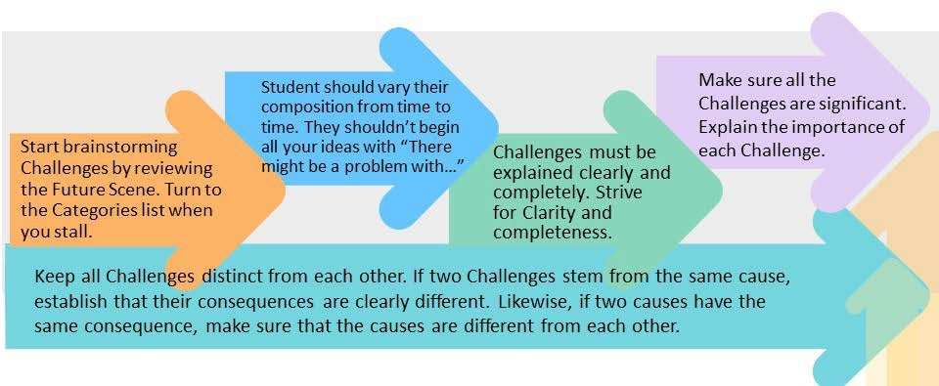

Key Concept of Webinar:
Applying analytical thinking skills to unpack a future scene, using the category list to identify problems and challenges from the future scene and write quality problems responding to the future scene.

Flexibility Warm Up
Topic:
Idea | Category
 | Arts & Aesthetics
 | Basic Needs
 | Business & Commerce
 | Communication
 | Defence
 | Economics
 | Education
 | Environmental
 | Ethics & Religion
 | Government & Politics
 | Law & Justice
 | Physical Health
 | Psychological Health
 | Recreation
 | Social Relationships
 | Technology
 | Transportation

Category List Worksheet
 | FS Link | Problem | Effect/Result | Category | Research
1
2
3
4
5
6
7
8
9
10
11
12
13
14
15
16

